# Assessment 3 Comprehensive Analysis of Climate Data

Untuk Part 1, seluruh dokumen yang berkaitan dapat diakses melalui link : https://drive.google.com/drive/folders/1N4a547MGp9yY2V5zI_029ic1i6kH-0RI?usp=sharing

**Part 1: SQL Database Setup and Queries.  
1.1 Database: SQL Query I**

1. **Import the downloaded dataset into an SQL database**

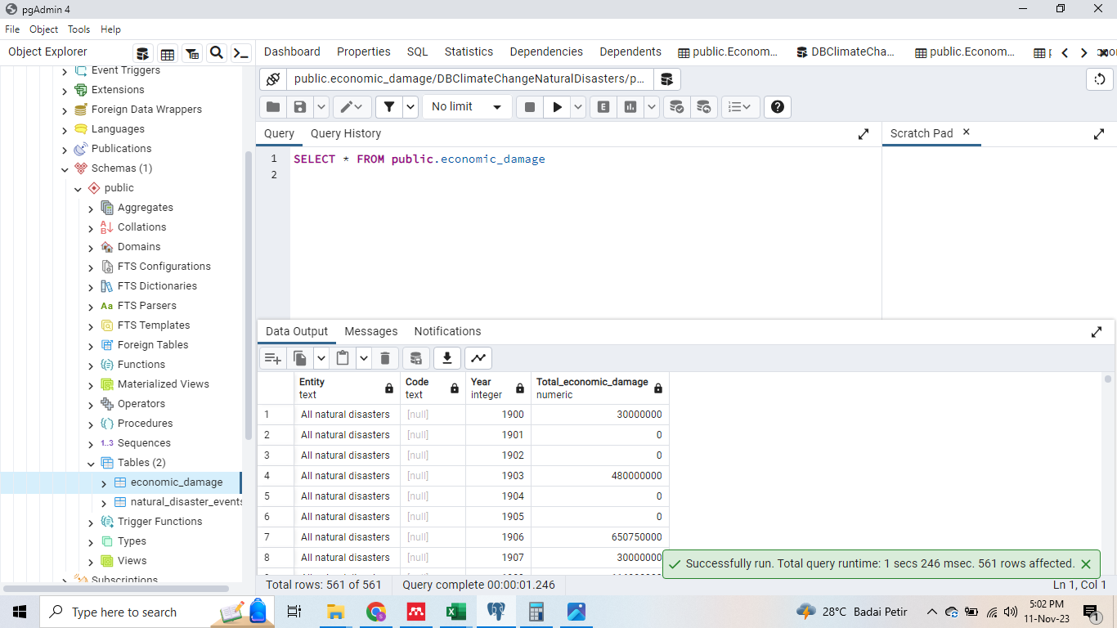

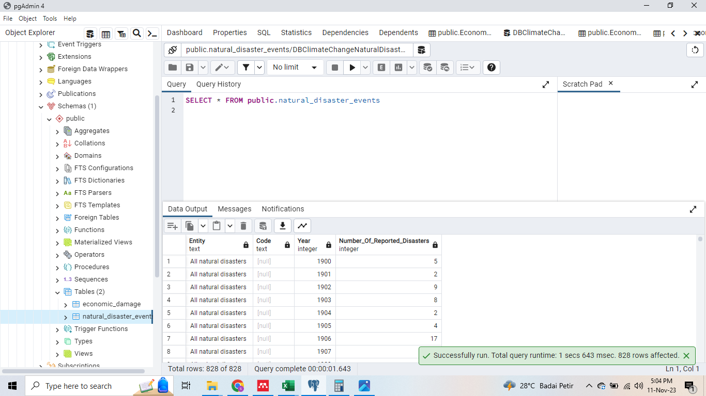

1. **Write an SQL query to fetch `Year` and any relevant variables (e.g., `Number of natural disasters`, `Economic damage`).**

| SELECT nd."Entity",  nd."Code",  nd."Year",  nd."Number_Of_Reported_Disasters" AS "Number of Reported Disasters",  ed."Total_economic_damage" AS "Total Economic Damage"  FROM natural_disaster_events AS nd  FULL OUTER JOIN economic_damage AS ed  ON nd."Entity" = ed."Entity"  AND nd."Year" = ed."Year"; |
| --- |

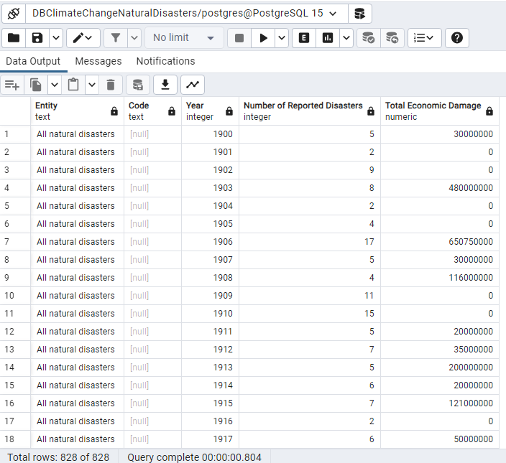

## **1.2 Database: SQL Query II**

1. **Write SQL query to show Total Natural Disaster and Economic Damage for every type of Disaster (Entity)**

| SELECT  nd."Entity",  SUM(nd."Number_Of_Reported_Disasters") AS "Total Reported Disasters",  SUM(ed."Total_economic_damage") AS "Total Economic Damage"  FROM  natural_disaster_events AS nd  FULL OUTER JOIN  economic_damage AS ed  ON  nd."Entity" = ed."Entity" AND nd."Year" = ed."Year"  GROUP BY  nd."Entity"; |
| --- |

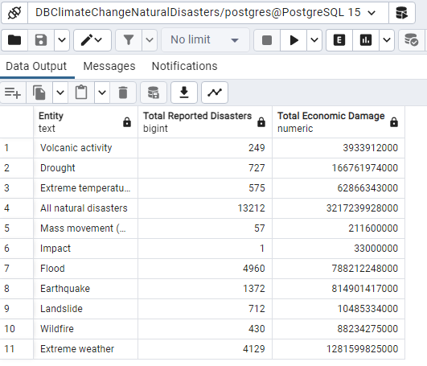

1. **Write an SQL query to summarize the data per 10 years, calculating averages and sums for Natural disaster & Economic damage.**

| SELECT  nd."Entity" AS "Type of Disaster",  MIN(nd."Year") || '-' || (MIN(nd."Year") + 9) AS "Start Year - End Year",  ROUND(AVG(nd."Number_Of_Reported_Disasters"), 2) AS "Avg Natural Disasters",  SUM(ed."Total_economic_damage") AS "Total Economic Damage"  FROM  natural_disaster_events AS nd  FULL OUTER JOIN  economic_damage AS ed  ON  nd."Entity" = ed."Entity" AND nd."Year" = ed."Year"  GROUP BY  "Type of Disaster", FLOOR(nd."Year" / 10)  ORDER BY  "Type of Disaster", FLOOR(nd."Year" / 10); |
| --- |

